# PeopleSafe - Eligibility Screen MBI/HICN (Processing Information)

Additional Eligibility Screen

Related Documents

**Description:** Instructions for utilizing the Additional Eligibility Screen to find the MBI (Medicare Beneficiary Identifier) numbers that took the place of the HICN (Health Insurance Claim Number) for all Medicare Members.

|  |
| --- |
| Additional Eligibility Screen |

**Claims Processing Info** fields are included on the Additional Eligibility screen in PeopleSafe.

Click the **Eligibility** button on the Main Screen of PeopleSafe to access the Additional Eligibility Screen.

The left-hand column provides the MBI/HICN, directly below the Internal ID. If the Member does not have Medicare, the field will be blank. Medicare Beneficiary Identifier (MBI) is an identifier introduced by CMS to replace the HICN for all Medicare Members.

At the bottom of the left-hand column, you will find the Medicare Type.

* M= Part A & B
* D= Part A & B Age 65
* B= Part B Only
* A= Part A Only

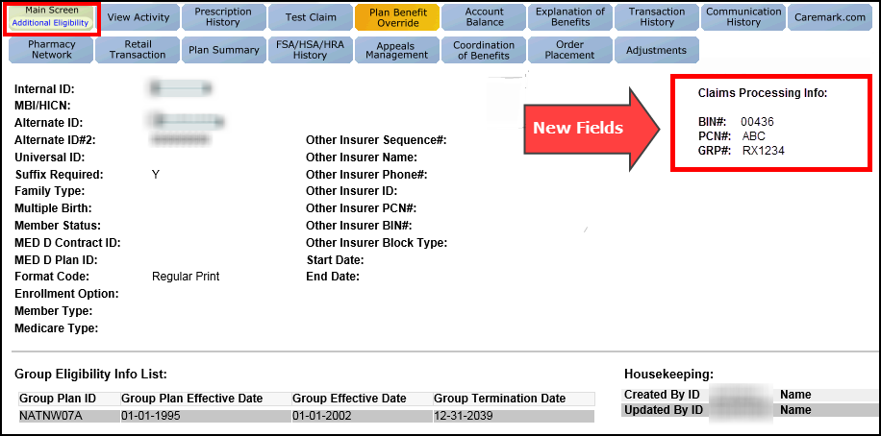

The right-hand column provides the claims processing information found in the Retail Logic section of the CIF:

* BIN#
* PCN#
* GRP# (**Example:** Group ID)

Top of the Document

|  |
| --- |
| Related Documents |

[Customer Care Abbreviations, Definitions, and Terms Index (014728)](https://thesource.cvshealth.com/nuxeo/thesource/#!/view?docid=c1f1028b-e42c-4b4f-a4cf-cc0b42c91606)

Top of the Document

Not to Be Reproduced or Disclosed to Others without Prior Written Approval

**ELECTRONIC DATA = OFFICIAL VERSION / PAPER COPY = INFORMATIONAL ONLY**